**Ex no: 5**

**Date: 19.03.2024**

**SYSTEM CALL TRACING**

**Aim:**

To write a C program and trace system calls used and print the same in ascending order using shell script.

output.

**Program Code:**ex5.c  
#include <stdio.h>

void main() {

printf("Hello World!\n");

}

Ex5.sh  
cat ex5trace | cut -f1 -d "("

**Output:**

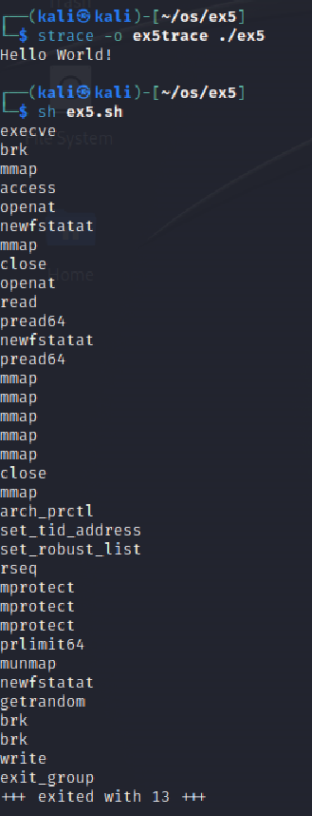

**Result:**

The above program executed successfully and output got verified.